Case 10-A1356-MEX-Maya-Chaac-Jadeite-Late Postclassic Period-1300-1500 CE

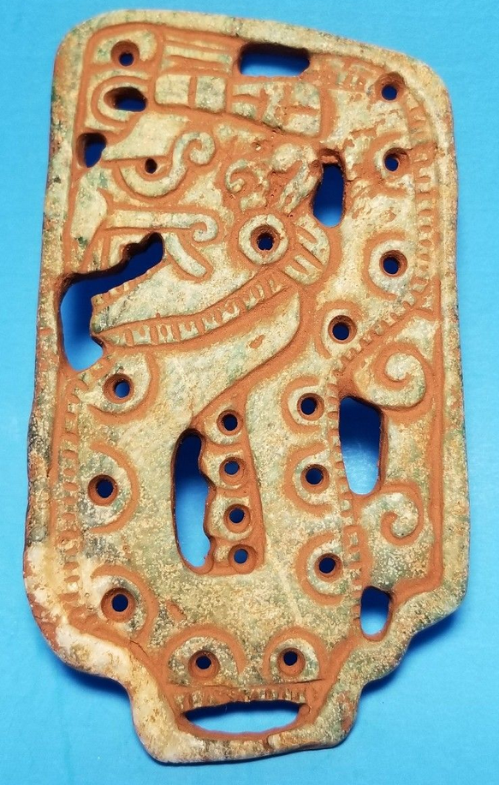  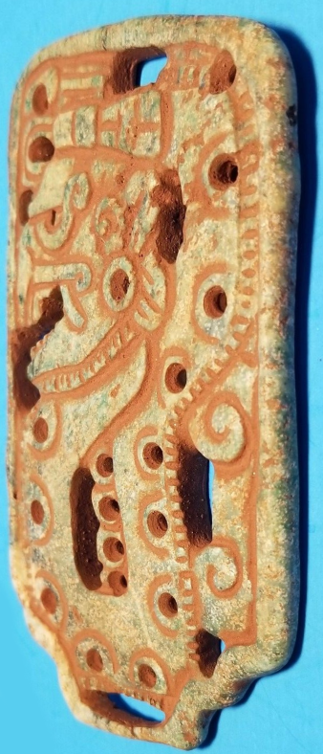

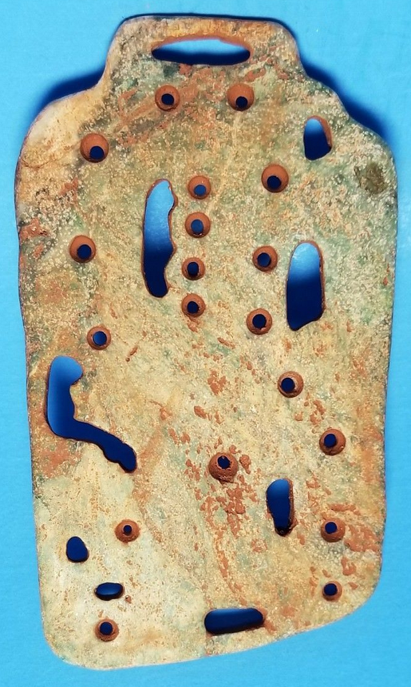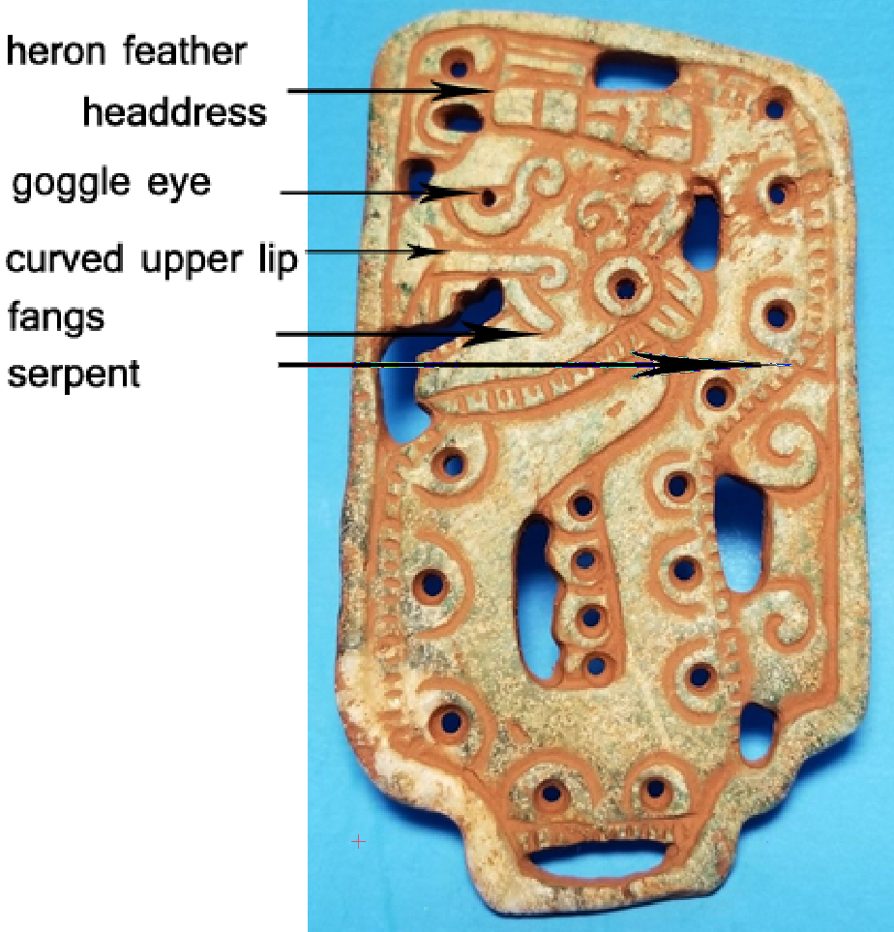

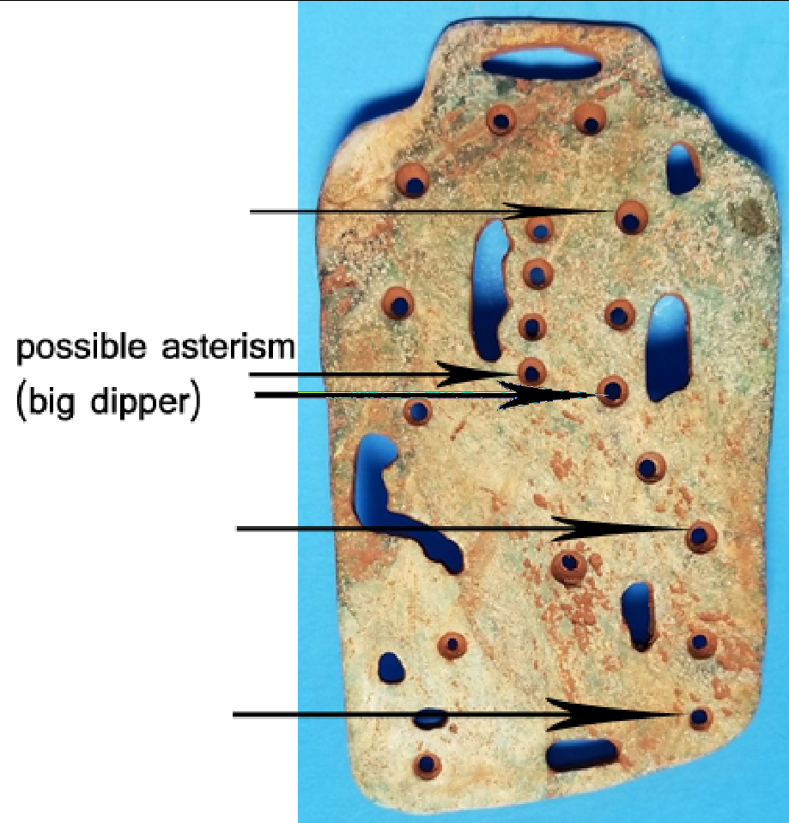

Figs. 1-6. Late Postclassic Chaac, ca. 1300 CE



Fig. 7. Current Late Postclassic plaque compared with Dresden Codex Chaac.

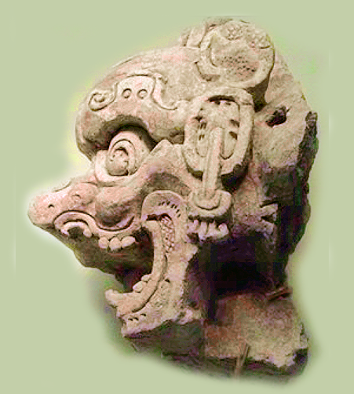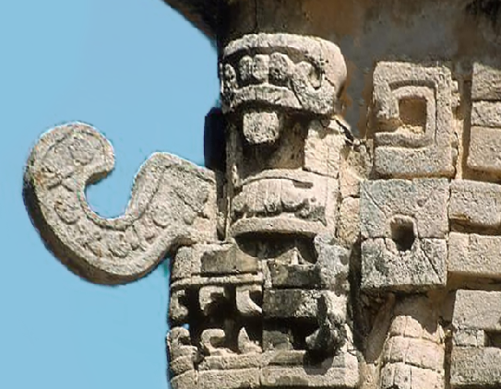

Figs. 8-9. Examples of Chaac symbolism from two different periods and cultural styles:

Fig. 8. Classic Period Maya Chaac (300-600 CE), Chinese Maya exhibit, Beijing, National Museum, 2018; After China Daily 2014, http://www.kaogu.cn/en/News/Academic_activities/2014/1118/48237.html.

Fig. 9. Terminal Classic (800–900 CE) to early Postclassic period (900–1200 CE) Chichen Itza, Northern Maya Lowlands, Mosaic Mask of **Sac Xib Chaac = White Chaac of the North**, Structure 3E1, Colonnade, Toltec Maya Style after https://upload.wikimedia.org/wikipedia/commons/thumb/7/72/Chichen-Itz%C3%A1_16.jpg/606px-Chichen-Itz%C3%A1_16.jpg.

**Case no.: 10**

**Accession Number:**

**Formal Label:** Maya-Chaac-Jadeite-Late Postclassic Period-1300-1500 CE

Display Description: Chaac God B, the rain god, is divided into its four cardinal directions according to that were probably associated with different weather events:

**Chacc Xib Chaac = Red Chaac of the East**

**Sac Xib Chaac or Zac Xib Chaac = White Chaac of the North**

**Ek Xib Chaac = Black Chaac of the West**

**Kan Xib Chaac = Yellow Chaac of the South**

**LC Classification:**

**Date or Time Horizon:** ca. 1300-1400 CE

**Geographical Area:**

**Map:**

**GPS coordinates:**

**Cultural Affiliation:** Maya Late Postclassic Period-1300-1500 CE

**Media:** marble, cinnabar (red pigment)

**Dimensions:** H 4 in, W 2.25 in

**Weight:**

**Condition: original**

**Provenance:** Northern Maya Lowlands

**Discussion:**

With regard to the verso of the Chaac plaque under investigation Robert L. Hall has made the following interesting archaeo-astronomical observation regarding the Big Dipper and the Milky Way (Hall 1997) as it may correlate with this plaque assuming it to reference **White Chaac of the North “**the MilkyWay at a time of the year when it was visible running north and south across the sky with the Big Dipper to one side near its northern end”**:**

As David Freidel, Linda Schele, Joy Parker, and colleagues read the *Maya* record, 17 Macaw was the personification of the *Big Dipper*, and the tree in which the *Maya* Hero Twins found 7 Macaw was perceived to be the Milky Way at a time of the year when it was visible running north and south across the sky with the Big Dipper to one side near its northern end. Bernardino de Sahagún identified the deity on top of the pole (read ‘tree’) in the Aztec Feast of the Dead as Otontecuhtli or god of the Otomies, and elsewhere he refers to as god of the Otomies.

**References:**

China Daily/ 2014. Mayan exhibition shows 'similarities' with Chinese. <http://www.kaogu.cn/en/News/Academic_activities/2014/1118/48237.html>

Hall, R.L., 1997. *An archaeology of the soul: North American Indian belief and ritual*. University of Illinois Press.